Project Information:

* What is the purpose of the site?

The purpose of this website is to demonstrate the things I have learned in this Web Technology course. I have decided to create a Porsche fan base website where you can learn more about Porsche’s.

* Who is your intended audience?   
    
  My target audience are Porsche enthusiasts that want to learn more about the website.
* What is the new web technology that you added to your website.  
    
  The new web technology I have added is scripts from Ionicons. This allows me to get free icons without having downloaded them or them being in my images folder.

    <!-- Contact section -->

    <h1 class="title">Contact</h1>

    <p class="para">Mail | GitHub | LinkedIn</p>

    <ul class="social-media-list">

        <!-- Social media icons with links -->

        <li><a href="mailto:contact@forestview.com" target="_blank" class="contact-icon">

            <ion-icon name="mail-outline"></ion-icon></a></li>

        <li><a href="https://github.com/IssaPortfolio" target="_blank" class="contact-icon">

            <ion-icon name="logo-github"></ion-icon></a></li>

        <li><a href="https://www.linkedin.com/school/wayne-state-university/" target="_blank" class="contact-icon">

            <ion-icon name="logo-linkedin"></ion-icon></a></li>

    </ul>

    <!-- Script for Ionicons -->

    <script type="module" src="https://unpkg.com/ionicons@5.5.2/dist/ionicons/ionicons.esm.js"></script>

    <script nomodule src="https://unpkg.com/ionicons@5.5.2/dist/ionicons/ionicons.js"></script>

* What opportunity, problem, or issue is your site addressing?

The opportunity it is addressing is learning more about Porsche.

* What type of content might be included in your site?   
    
  The content are images, videos, and a login (which can be used to create a forum page in the future).
* List at least two related or similar sites found on the web.  
    
  1. <https://rennlist.com/>

2. <https://www.pca.org/>

Site Map:

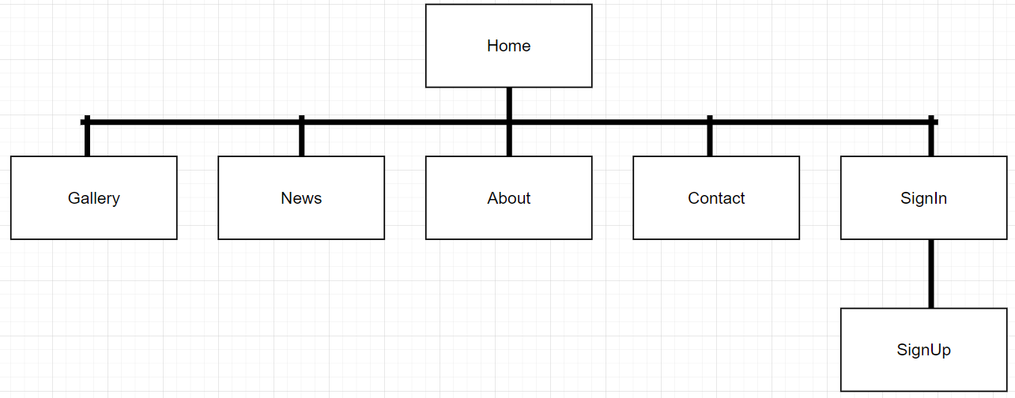

Website Images:

Home:

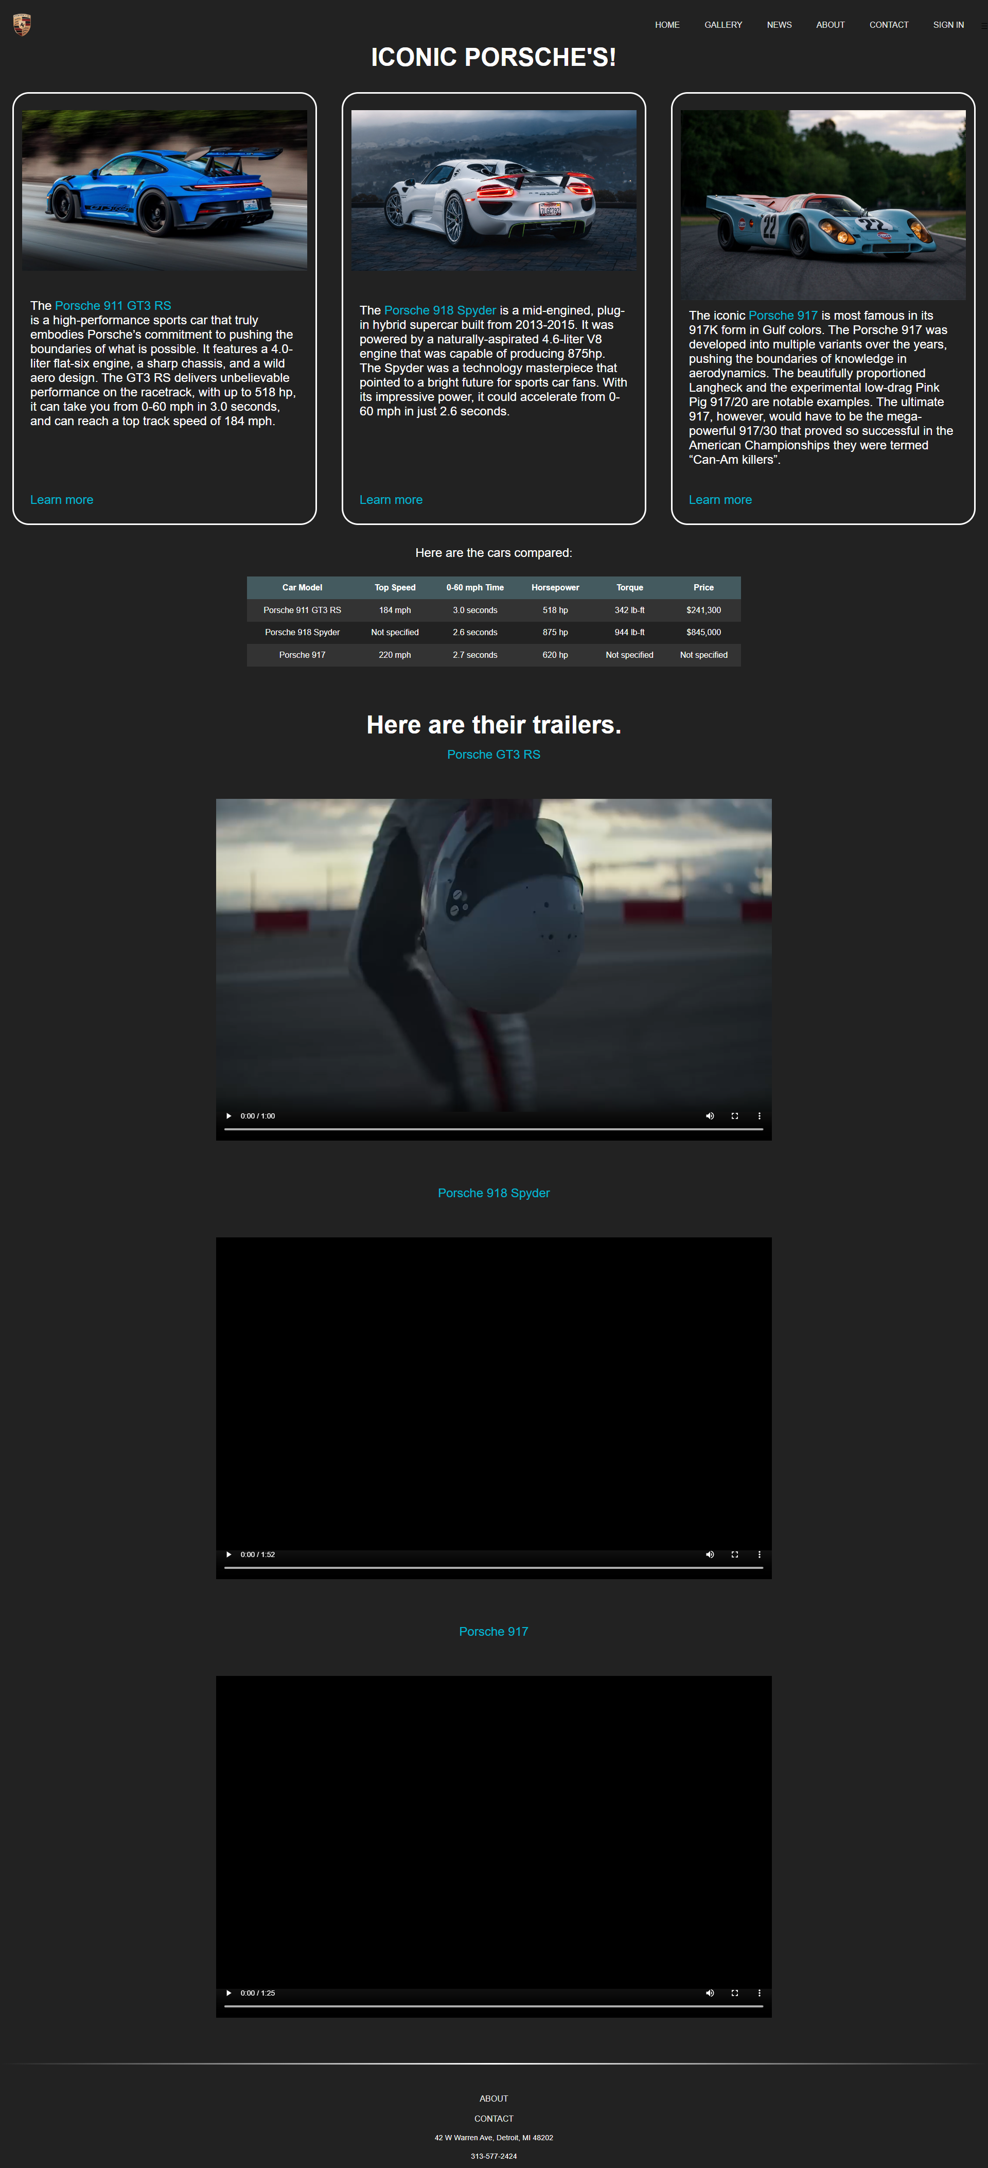

Gallery:

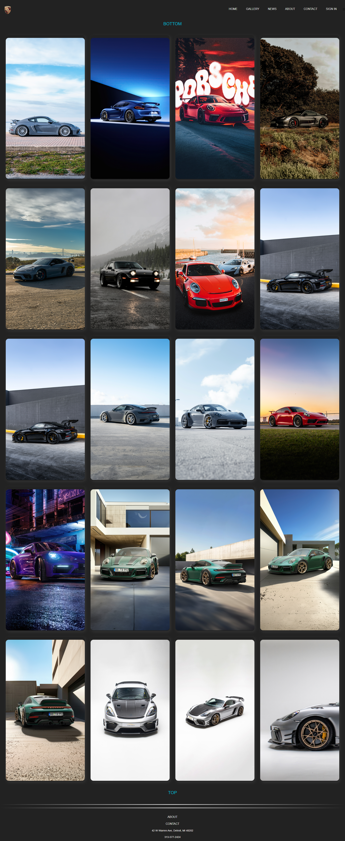

News:

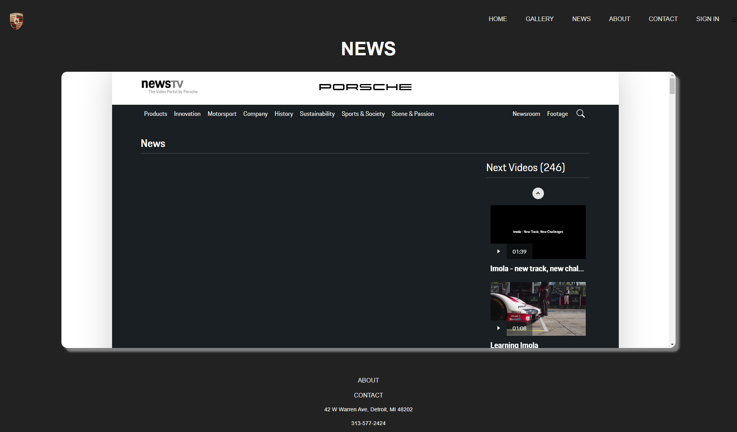

About:

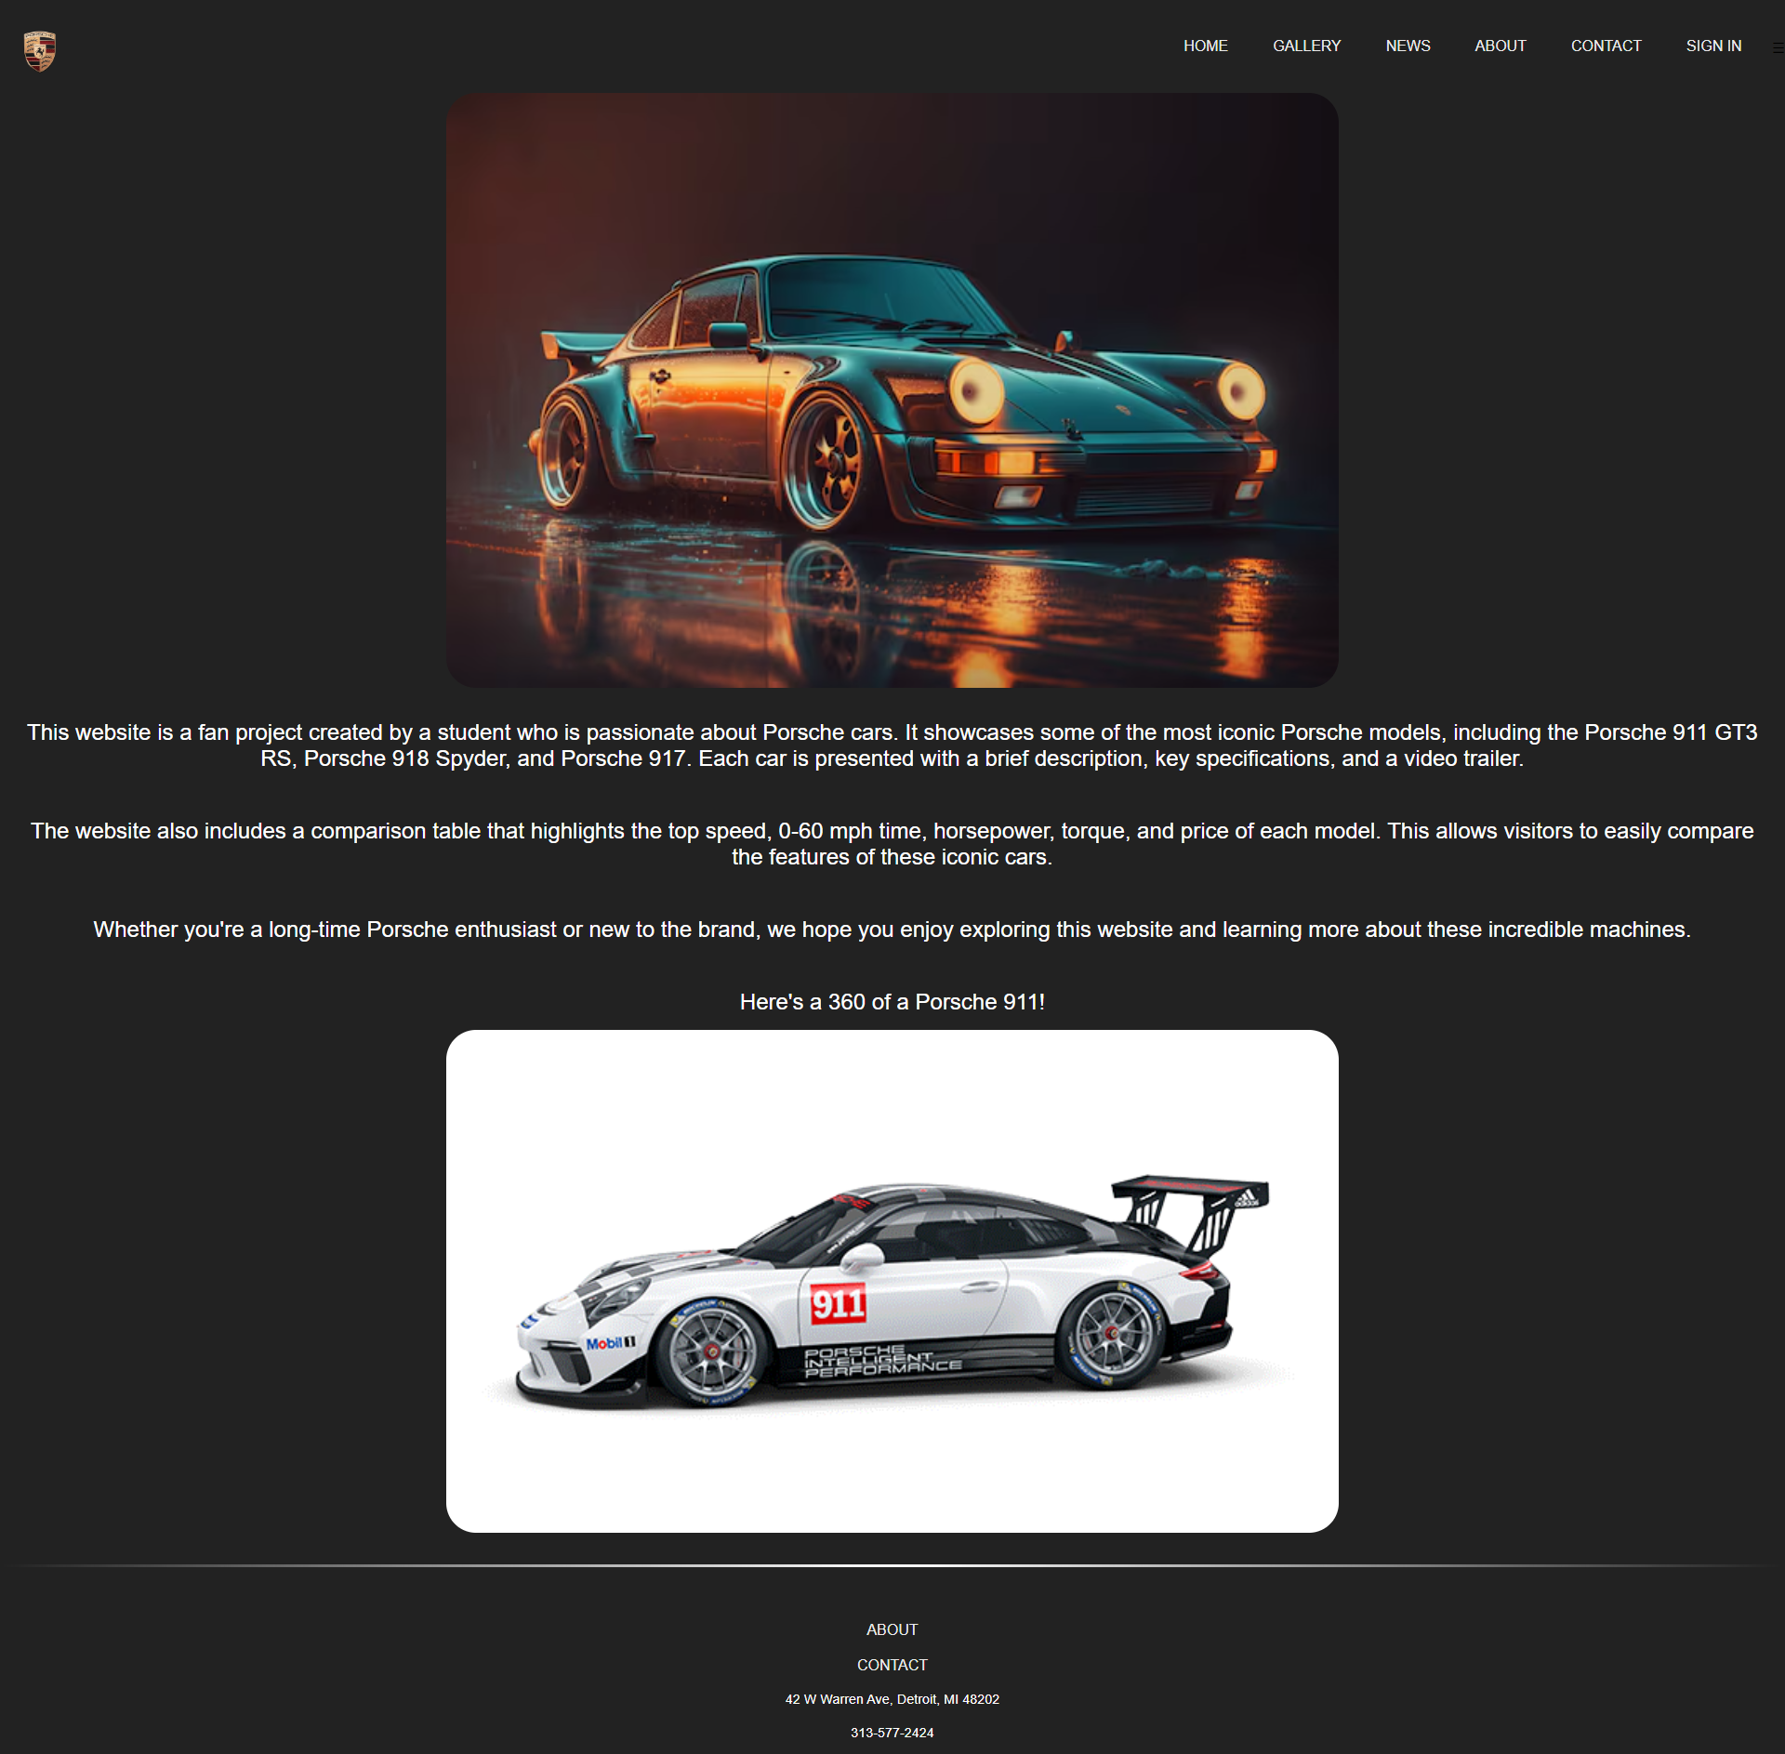

Contact:

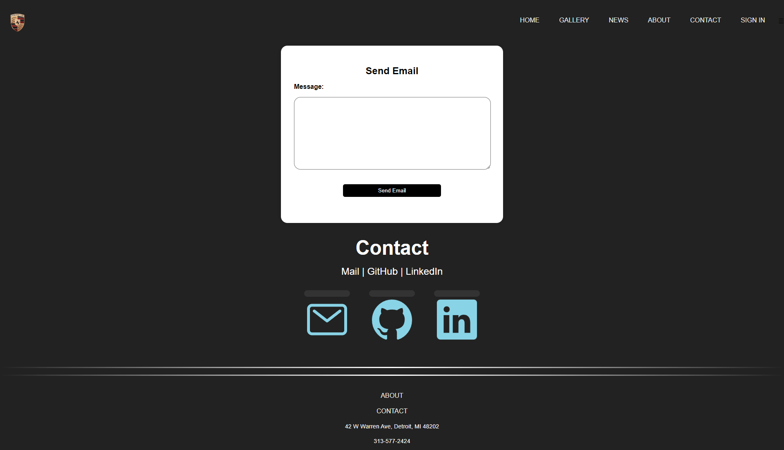

Sign In:

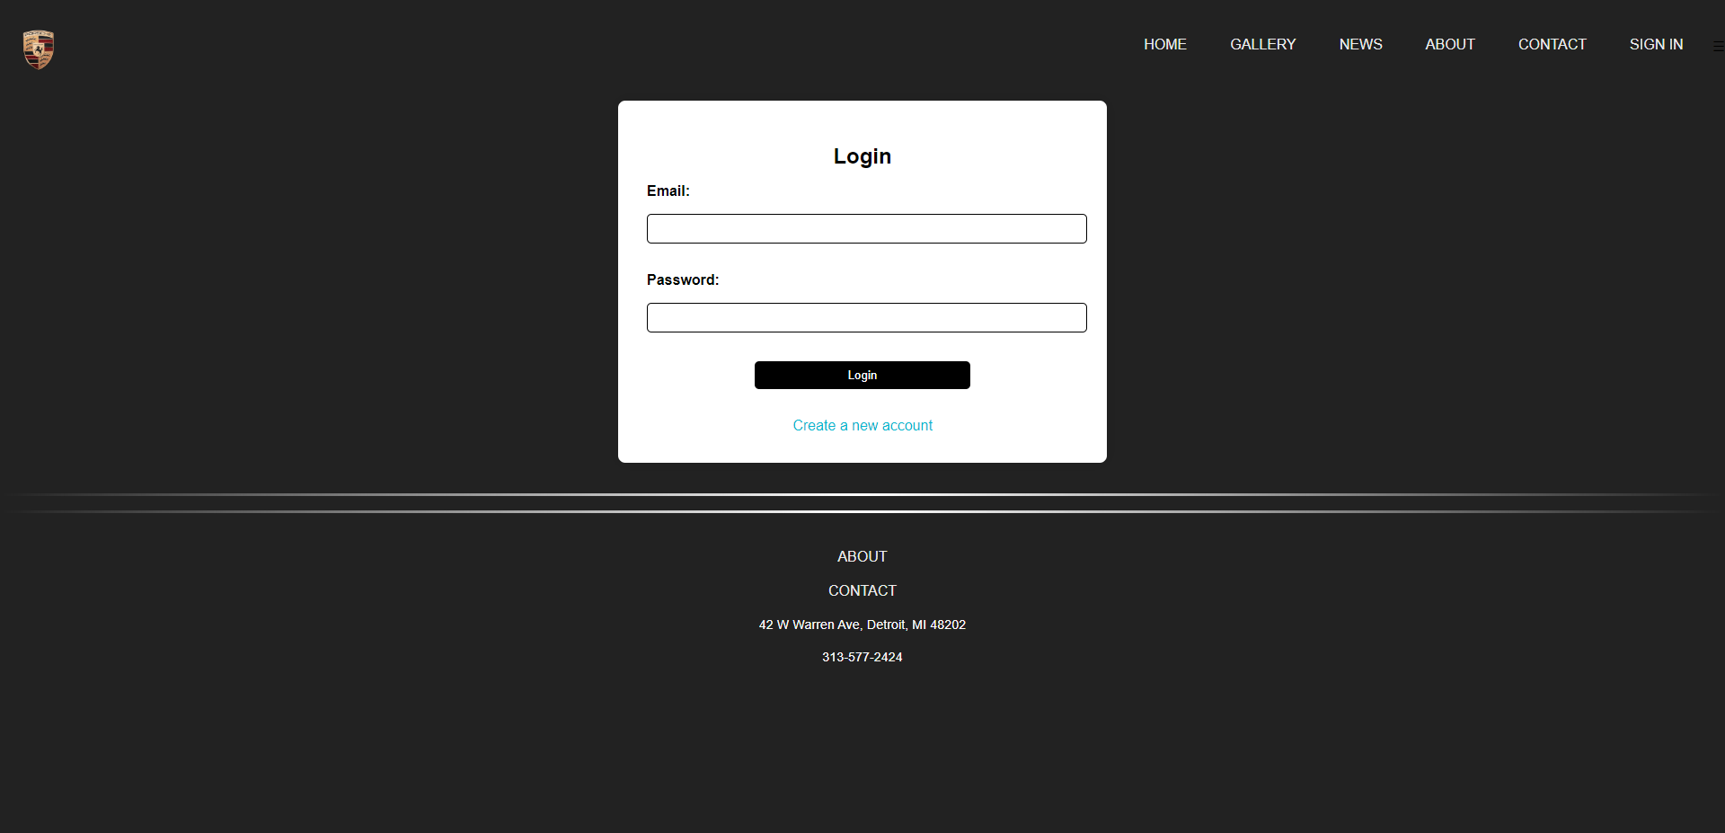

Sign Up:

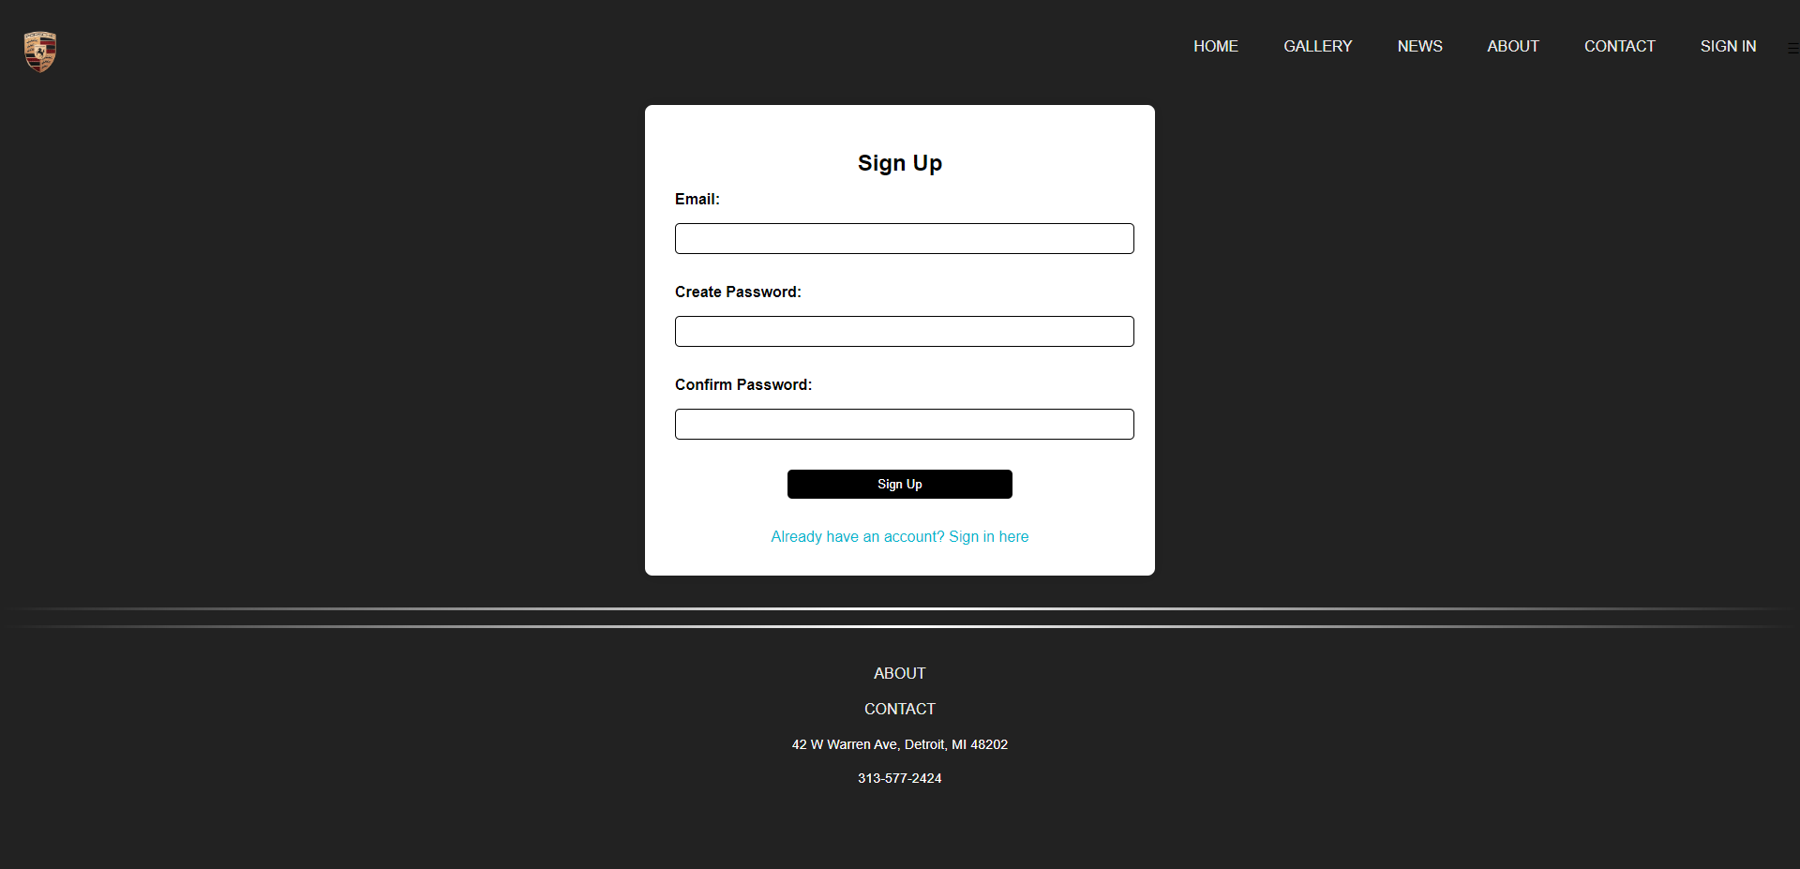

Responsive Design:

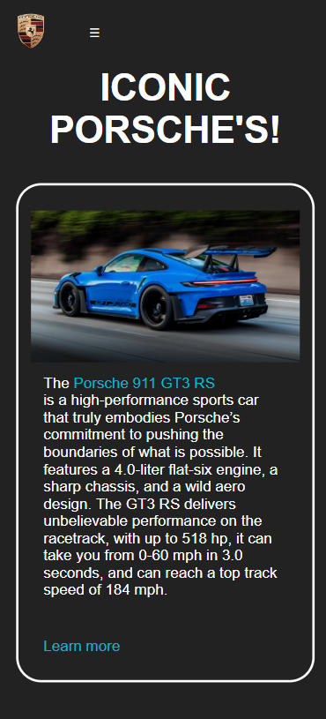

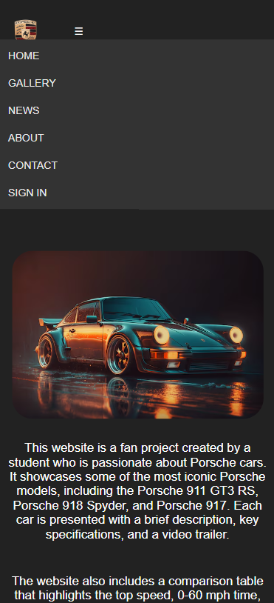

Code:

home.html

<!DOCTYPE html>

<html>

<head>

    <!-- Title of the page visible on the browser tab -->

    <title>My Porsche Website</title>

    <!-- Link to the external CSS for styling -->

    <link rel="stylesheet" type="text/css" href="css/style.css">

    <!-- Meta tag for setting the viewport to scale for different devices -->

    <meta name="viewport" content="width=device-width, initial-scale=1">

    <!-- Website favicon -->

    <link rel="icon" href="Images/logo.png">

</head>

<body>

    <!-- Container for the header section -->

    <div>

        <header>

            <!-- Website logo -->

            <img src="Images/logo.png" alt="Logo" class="logo">

            <!-- Navigation menu -->

            <ul class="menu" id="menu">

                <li><a href="home.html">HOME</a></li>

                <li><a href="pages/gallery.html">GALLERY</a></li>

                <li><a href="pages/news.html">NEWS</a></li>

                <li><a href="pages/about.html">ABOUT</a></li>

                <li><a href="pages/contact.html">CONTACT</a></li>

                <li><a href="pages/signin.html">SIGN IN</a></li>

            </ul>

            <!-- Menu icon for mobile view -->

            <div class="menu-icon" id="menu-icon">☰</div>

        </header>

    </div>

    <!-- Script to handle menu toggle on small screens -->

    <script>

        document.getElementById('menu-icon').addEventListener('click', function() {

            var menu = document.getElementById('menu');

            var body = document.body;

            if (menu.classList.contains('active')) {

                menu.classList.remove('active');

                body.style.marginTop = '0';

            } else {

                menu.classList.add('active');

                body.style.marginTop = '20rem';

            }

        });

    </script>

    <!-- Main content starts here -->

    <br><br>

    <h1>ICONIC PORSCHE'S!</h1>

    <!-- Row for flex display of columns -->

    <div class="row">

        <!-- Each column represents one car -->

        <div class="column">

            <img src="Images/porsche1.jpg" alt="Porsche 911 GT3 RS">

            <p>The <a href="#GT3RS">Porsche 911 GT3 RS</a><br /> is a high-performance sports car that truly embodies Porsche’s commitment

                to pushing the boundaries of what is possible. It features a 4.0-liter flat-six engine, a sharp

                chassis, and a wild aero design. The GT3 RS delivers unbelievable performance on the racetrack,

                with up to 518 hp, it can take you from 0-60 mph in 3.0 seconds, and can reach a top track speed of 184 mph.</p>

            <br>

            <p><a href="https://www.porsche.com/stories/innovation/eight-things-you-need-to-know-about-the-911-gt3" target="_blank">Learn more</a></p>

        </div>

        <div class="column">

            <img src="Images/porsche2.jpg" alt="Porsche 918 Spyder">

            <p>The <a href="#918">Porsche 918 Spyder</a> is a mid-engined, plug-in hybrid supercar built from 2013-2015. It was

                powered by a naturally-aspirated 4.6-liter V8 engine that was capable of producing 875hp. The

                Spyder was a technology masterpiece that pointed to a bright future for sports car fans. With

                its impressive power, it could accelerate from 0-60 mph in just 2.6 seconds.</p>

            <br>

            <p><a href="https://www.porsche.com/stories/innovation/how-much-is-a-porsche-918-spyder" target="_blank">Learn more</a></p>

        </div>

        <div class="column">

            <img src="Images/porsche3.jpg" alt="Porsche 917">

            <p>The iconic <a href="#917">Porsche 917</a> is most famous in its 917K form in Gulf colors. The Porsche 917 was developed

                into multiple variants over the years, pushing the boundaries of knowledge in aerodynamics. The

                beautifully proportioned Langheck and the experimental low-drag Pink Pig 917/20 are notable examples.

                The ultimate 917, however, would have to be the mega-powerful 917/30 that proved so successful in the

                American Championships they were termed “Can-Am killers”.</p>

            <br>

            <p><a href="https://www.porsche.com/stories/innovation/why-the-porsche-917-is-a-gamechanger" target="_blank">Learn more</a></p>

        </div>

    </div>

    <!-- Comparing car specifications -->

    <p>Here are the cars compared:</p>

    <div class="table-container">

        <table>

            <!-- Table headings -->

            <tr>

                <th>Car Model</th>

                <th>Top Speed</th>

                <th>0-60 mph Time</th>

                <th>Horsepower</th>

                <th>Torque</th>

                <th>Price</th>

            </tr>

            <!-- Data rows for each car -->

            <tr>

                <td>Porsche 911 GT3 RS</td>

                <td>184 mph</td>

                <td>3.0 seconds</td>

                <td>518 hp</td>

                <td>342 lb-ft</td>

                <td>$241,300</td>

            </tr>

            <tr>

                <td>Porsche 918 Spyder</td>

                <td>Not specified</td>

                <td>2.6 seconds</td>

                <td>875 hp</td>

                <td>944 lb-ft</td>

                <td>$845,000</td>

            </tr>

            <tr>

                <td>Porsche 917</td>

                <td>220 mph</td>

                <td>2.7 seconds</td>

                <td>620 hp</td>

                <td>Not specified</td>

                <td>Not specified</td>

            </tr>

        </table>

    </div>

    <!-- Video section for different Porsche models -->

    <br><br id = "GT3RS"><br>

    <h1>Here are their trailers.</h1>

    <p><a href="https://www.youtube.com/watch?v=478Ay_lNpT4&t=1s" target="_blank" >Porsche GT3 RS</a></p>

    <video width="1080" height="720" controls>

        <source src="Videos/Porsche 911 GT3 RS.mp4" type="video/mp4">

        Your browser does not support the video tag.

    </video>

    <br id = "918"><br><br><br>

    <p><a href="https://www.youtube.com/watch?v=Wo_6X25DXAQ&t=10s" target="_blank" >Porsche 918 Spyder</a></p>

    <video width="1080" height="720" controls>

        <source src="Videos/Porsche 918 Spyder.mp4" type="video/mp4">

        Your browser does not support the video tag.

    </video>

    <br id = "917"><br><br><br>

    <p><a href="https://www.youtube.com/watch?v=WwKJZwtiRT8" target="_blank" >Porsche 917</a></p>

    <video width="1080" height="720" controls>

        <source src="Videos/Porsche 917.mp4" type="video/mp4">

        Your browser does not support the video tag.

    </video>

    <br><br><br>

    <br>

    <hr><hr>

    <br>

    <!-- Footer section -->

    <footer>

    <ul class = "footer">

        <li><a href = "about.html">ABOUT</a></li>

        <li><a href = "contact.html">CONTACT</a></li>

        <li>42 W Warren Ave, Detroit, MI 48202</li>

        <li>313-577-2424</li>

    </ul>

    </footer>

</body>

</html>

gallery.html

<!DOCTYPE html>

<html>

<head>

    <title>My Porsche Website</title> <!-- Title of the webpage -->

    <link rel="stylesheet" type="text/css" href="../css/style.css"> <!-- Link to external CSS file for styling -->

    <meta name="viewport" content="width=device-width, initial-scale=1"> <!-- Meta tag for responsive design -->

    <link rel="icon" href="../Images/logo.png"> <!-- Website favicon -->

</head>

<body>

    <div>

        <header>

            <a href="home.html">

                <img src="../Images/logo.png" alt="Logo" class="logo"> <!-- Website logo -->

            </a>

            <ul class="menu" id="menu">

                <!-- Navigation menu -->

                <li><a href="../home.html">HOME</a></li>

                <li><a href="gallery.html">GALLERY</a></li>

                <li><a href="news.html">NEWS</a></li>

                <li><a href="about.html">ABOUT</a></li>

                <li><a href="contact.html">CONTACT</a></li>

                <li><a href="signin.html">SIGN IN</a></li>

            </ul>

            <div class="menu-icon" id="menu-icon">☰</div>  <!-- Hamburger menu icon for mobile view -->

        </header>

    </div>

    <!-- JavaScript to toggle the menu visibility on mobile devices -->

    <script>

        document.getElementById('menu-icon').addEventListener('click', function() {

            var menu = document.getElementById('menu');

            var body = document.body;

            if (menu.classList.contains('active')) {

                menu.classList.remove('active');

                body.style.marginTop = '0';

            } else {

                menu.classList.add('active');

                body.style.marginTop = '20rem';

            }

        });

    </script>

    <br><br><br>

    <p id="top"><a href="#bottom">BOTTOM</a></p> <!-- Quick navigation link to the bottom of the page -->

    <div class="gallery">

        <!-- Gallery of images -->

        <div class="image"><img src="../Images/Gallery/1.jpg" alt="Porsche"></div>

        <div class="image"><img src="../Images/Gallery/2.jpg" alt="Porsche"></div>

        <div class="image"><img src="../Images/Gallery/3.jpg" alt="Porsche"></div>

        <div class="image"><img src="../Images/Gallery/4.jpg" alt="Porsche"></div>

        <div class="image"><img src="../Images/Gallery/5.jpg" alt="Porsche"></div>

        <div class="image"><img src="../Images/Gallery/6.jpg" alt="Porsche"></div>

        <div class="image"><img src="../Images/Gallery/7.jpg" alt="Porsche"></div>

        <div class="image"><img src="../Images/Gallery/8.jpg" alt="Porsche"></div>

        <div class="image"><img src="../Images/Gallery/9.jpg" alt="Porsche"></div>

        <div class="image"><img src="../Images/Gallery/10.jpg" alt="Porsche"></div>

        <div class="image"><img src="../Images/Gallery/11.jpg" alt="Porsche"></div>

        <div class="image"><img src="../Images/Gallery/12.jpg" alt="Porsche"></div>

        <div class="image"><img src="../Images/Gallery/13.jpg" alt="Porsche"></div>

        <div class="image"><img src="../Images/Gallery/14.jpg" alt="Porsche"></div>

        <div class="image"><img src="../Images/Gallery/15.jpg" alt="Porsche"></div>

        <div class="image"><img src="../Images/Gallery/16.jpg" alt="Porsche"></div>

        <div class="image"><img src="../Images/Gallery/17.jpg" alt="Porsche"></div>

        <div class="image"><img src="../Images/Gallery/18.jpg" alt="Porsche"></div>

        <div class="image"><img src="../Images/Gallery/19.jpg" alt="Porsche"></div>

        <div class="image"><img src="../Images/Gallery/20.jpg" alt="Porsche"></div>

    </div>

    <p id="bottom"><a href="#top">TOP</a></p> <!-- Quick navigation link to the top of the page -->

    <br>

    <hr><hr>

    <br>

    <footer>

        <!-- Footer with navigation links and contact information -->

        <ul class="footer">

            <li><a href="about.html">ABOUT</a></li>

            <li><a href="contact.html">CONTACT</a></li>

            <li>42 W Warren Ave, Detroit, MI 48202</li>

            <li>313-577-2424</li>

        </ul>

    </footer>

</body>

</html>

news.html

<!DOCTYPE html> <!-- Document type declaration -->

<html>

<head>

    <title>My Porsche Website</title> <!-- Title of the webpage -->

    <link rel="stylesheet" type="text/css" href="../css/style.css"> <!-- Link to external CSS file -->

    <meta name="viewport" content="width=device-width, initial-scale=1"> <!-- Meta tag for responsive design -->

    <link rel="icon" href="../Images/logo.png"> <!-- Favicon for the website -->

</head>

<body>

    <div>

        <header>

            <a href="home.html">

                <img src="../Images/logo.png" alt="Logo" class="logo"> <!-- Website logo -->

            </a> <!-- Website logo -->

            <ul class="menu" id="menu">

                <!-- Navigation menu -->

                <li><a href="../home.html">HOME</a></li>

                <li><a href="gallery.html">GALLERY</a></li>

                <li><a href="news.html">NEWS</a></li>

                <li><a href="about.html">ABOUT</a></li>

                <li><a href="contact.html">CONTACT</a></li>

                <li><a href="signin.html">SIGN IN</a></li>

            </ul>

            <div class="menu-icon" id="menu-icon">☰</div>  <!-- Hamburger menu icon for mobile view -->

        </header>

    </div>

    <!-- JavaScript for toggling the menu -->

    <script>

        document.getElementById('menu-icon').addEventListener('click', function() {

            var menu = document.getElementById('menu');

            var body = document.body;

            if (menu.classList.contains('active')) {

                menu.classList.remove('active');

                body.style.marginTop = '0';

            } else {

                menu.classList.add('active');

                body.style.marginTop = '20rem';

            }

        });

    </script>

    <br><br>

    <h1>NEWS</h1> <!-- News section heading -->

    <div class="iframe-container">

        <iframe class="styled-iframe" src="https://newstv.porsche.com/en/"></iframe> <!-- Embedded iframe for displaying news -->

    </div>

    <br><br><br>

    <!-- Footer section -->

    <footer>

        <ul class="footer">

            <!-- Footer navigation links -->

            <li><a href="about.html">ABOUT</a></li>

            <li><a href="contact.html">CONTACT</a></li>

            <!-- Contact information -->

            <li>42 W Warren Ave, Detroit, MI 48202</li>

            <li>313-577-2424</li>

        </ul>

    </footer>

</body>

</html>

about.html

<!DOCTYPE html> <!-- Document type declaration -->

<html>

<head>

    <title>My Porsche Website</title> <!-- Title of the webpage -->

    <link rel="stylesheet" type="text/css" href="../css/style.css"> <!-- Link to external CSS file -->

    <meta name="viewport" content="width=device-width, initial-scale=1"> <!-- Meta tag for responsive design -->

    <link rel="icon" href="../Images/logo.png"> <!-- Favicon for the website -->

</head>

<body>

    <div>

        <header>

            <a href="home.html">

                <img src="../Images/logo.png" alt="Logo" class="logo"> <!-- Website logo -->

            </a> <!-- Website logo -->

            <ul class="menu" id="menu">

                <!-- Navigation menu -->

                <li><a href="../home.html">HOME</a></li>

                <li><a href="gallery.html">GALLERY</a></li>

                <li><a href="news.html">NEWS</a></li>

                <li><a href="about.html">ABOUT</a></li>

                <li><a href="contact.html">CONTACT</a></li>

                <li><a href="signin.html">SIGN IN</a></li>

            </ul>

            <div class="menu-icon" id="menu-icon">☰</div> <!-- Hamburger menu icon for mobile view -->

        </header>

    </div>

    <!-- JavaScript for toggling the menu -->

    <script>

        document.getElementById('menu-icon').addEventListener('click', function() {

            var menu = document.getElementById('menu');

            var body = document.body;

            if (menu.classList.contains('active')) {

                menu.classList.remove('active');

                body.style.marginTop = '0';

            } else {

                menu.classList.add('active');

                body.style.marginTop = '20rem';

            }

        });

    </script>

    <br><br>

    <!-- Fan art image section -->

    <div class="image-fanart">

        <img src="../Images/fanart.avif" alt="Fan Art">

    </div>

    <br>

    <!-- Introduction section -->

    <p>This website is a fan project created by a student who is passionate about Porsche cars.

        It showcases some of the most iconic Porsche models, including the Porsche 911 GT3 RS,

        Porsche 918 Spyder, and Porsche 917. Each car is presented with a brief description, key

        specifications, and a video trailer.</p>

    <br>

    <!-- Features section -->

    <p>The website also includes a comparison table that highlights the top speed, 0-60 mph time,

        horsepower, torque, and price of each model. This allows visitors to easily compare the

        features of these iconic cars.</p>

    <br>

    <!-- Closing message section -->

    <p>Whether you're a long-time Porsche enthusiast or new to the brand, we hope you enjoy exploring

        this website and learning more about these incredible machines.</p>

    <br>

    <!-- Porsche 911 360-degree GIF section -->

    <p>Here's a 360 of a Porsche 911!</p>

    <div class="image-fanart">

        <img src="../Images/porschegif.gif" alt="Gif">

    </div>

    <br>

    <hr><hr> <!-- Horizontal rule -->

    <br>

    <!-- Footer section -->

    <footer>

        <ul class="footer">

            <!-- Footer navigation links -->

            <li><a href="about.html">ABOUT</a></li>

            <li><a href="contact.html">CONTACT</a></li>

            <!-- Contact information -->

            <li>42 W Warren Ave, Detroit, MI 48202</li>

            <li>313-577-2424</li>

        </ul>

    </footer>

</body>

</html>

contact.html

<!DOCTYPE html> <!-- Document type declaration -->

<html>

<head>

    <title>My Porsche Website</title> <!-- Title of the webpage -->

    <link rel="stylesheet" type="text/css" href="../css/style.css"> <!-- Link to external CSS file -->

    <meta name="viewport" content="width=device-width, initial-scale=1"> <!-- Meta tag for responsive design -->

    <link rel="icon" href="../Images/logo.png"> <!-- Favicon for the website -->

</head>

<body>

    <div>

        <header>

            <a href="home.html">

                <img src="../Images/logo.png" alt="Logo" class="logo"> <!-- Website logo -->

            </a> <!-- Website logo -->

            <ul class="menu" id="menu">

                <!-- Navigation menu -->

                <li><a href="../home.html">HOME</a></li>

                <li><a href="gallery.html">GALLERY</a></li>

                <li><a href="news.html">NEWS</a></li>

                <li><a href="about.html">ABOUT</a></li>

                <li><a href="contact.html">CONTACT</a></li>

                <li><a href="signin.html">SIGN IN</a></li>

            </ul>

            <div class="menu-icon" id="menu-icon">☰</div> <!-- Hamburger menu icon for mobile view -->

        </header>

    </div>

    <!-- JavaScript for toggling the menu -->

    <script>

        document.getElementById('menu-icon').addEventListener('click', function() {

            var menu = document.getElementById('menu');

            var body = document.body;

            if (menu.classList.contains('active')) {

                menu.classList.remove('active');

                body.style.marginTop = '0';

            } else {

                menu.classList.add('active');

                body.style.marginTop = '20rem';

            }

        });

    </script>

    <!-- Message form section -->

    <div class="message-form">

        <h2>Send Email</h2>

        <form action="mailto:fakemail@gmail.com" method="post" enctype="text/plain">

            <div class="form-group">

                <label for="message">Message:</label>

                <textarea id="message" name="message" rows="3" required></textarea>

            </div>

            <div class="form-group">

                <input type="submit" value="Send Email">

            </div>

        </form>

    </div>

    <br>

    <!-- Contact section -->

    <h1 class="title">Contact</h1>

    <p class="para">Mail | GitHub | LinkedIn</p>

    <ul class="social-media-list">

        <!-- Social media icons with links -->

        <li><a href="mailto:contact@forestview.com" target="_blank" class="contact-icon">

            <ion-icon name="mail-outline"></ion-icon></a></li>

        <li><a href="https://github.com/IssaPortfolio" target="_blank" class="contact-icon">

            <ion-icon name="logo-github"></ion-icon></a></li>

        <li><a href="https://www.linkedin.com/school/wayne-state-university/" target="_blank" class="contact-icon">

            <ion-icon name="logo-linkedin"></ion-icon></a></li>

    </ul>

    <!-- Script for Ionicons -->

    <script type="module" src="https://unpkg.com/ionicons@5.5.2/dist/ionicons/ionicons.esm.js"></script>

    <script nomodule src="https://unpkg.com/ionicons@5.5.2/dist/ionicons/ionicons.js"></script>

    <br>

    <hr><hr> <!-- Horizontal rule -->

    <br>

    <!-- Footer section -->

    <footer>

        <ul class="footer">

            <!-- Footer navigation links -->

            <li><a href="about.html">ABOUT</a></li>

            <li><a href="contact.html">CONTACT</a></li>

            <!-- Contact information -->

            <li>42 W Warren Ave, Detroit, MI 48202</li>

            <li>313-577-2424</li>

        </ul>

    </footer>

    <!-- External scripts for jQuery and Bootstrap -->

    <script src="https://code.jquery.com/jquery-3.3.1.slim.min.js"></script>

    <script src="https://stackpath.bootstrapcdn.com/bootstrap/4.3.1/js/bootstrap.min.js"></script>

</body>

</html>

signin.html

<!DOCTYPE html> <!-- Document type declaration -->

<html>

<head>

    <title>My Porsche Website</title> <!-- Title of the webpage -->

    <link rel="stylesheet" type="text/css" href="../css/style.css"> <!-- Link to external CSS file -->

    <meta name="viewport" content="width=device-width, initial-scale=1"> <!-- Meta tag for responsive design -->

    <link rel="icon" href="Images/logo.png"> <!-- Favicon for the website -->

</head>

<body>

    <div>

        <header>

            <a href="home.html">

                <img src="../Images/logo.png" alt="Logo" class="logo"> <!-- Website logo -->

            </a> <!-- Website logo -->

            <ul class="menu" id="menu">

                <!-- Navigation menu -->

                <li><a href="../home.html">HOME</a></li>

                <li><a href="gallery.html">GALLERY</a></li>

                <li><a href="news.html">NEWS</a></li>

                <li><a href="about.html">ABOUT</a></li>

                <li><a href="contact.html">CONTACT</a></li>

                <li><a href="signin.html">SIGN IN</a></li>

            </ul>

            <div class="menu-icon" id="menu-icon">☰</div> <!-- Hamburger menu icon for mobile view -->

        </header>

    </div>

    <!-- JavaScript for toggling the menu -->

    <script>

        document.getElementById('menu-icon').addEventListener('click', function() {

            var menu = document.getElementById('menu');

            var body = document.body;

            if (menu.classList.contains('active')) {

                menu.classList.remove('active');

                body.style.marginTop = '0';

            } else {

                menu.classList.add('active');

                body.style.marginTop = '20rem';

            }

        });

    </script>

    <!-- Sign-in form section -->

    <div class="signin">

        <h2>Login</h2>

        <form action="#" method="post">

            <div class="form-group">

                <label for="email">Email:</label>

                <input type="email" id="email" name="email" required>

            </div>

            <div class="form-group">

                <label for="password">Password:</label>

                <input type="password" id="password" name="password" required>

            </div>

            <div class="form-group">

                <input type="submit" value="Login">

            </div>

        </form>

        <div class="create-account">

            <a href="Other/signup.html">Create a new account</a> <!-- Link to sign-up page -->

        </div>

    </div>

    <br>

    <hr><hr> <!-- Horizontal rule -->

    <br>

    <!-- Footer section -->

    <footer>

        <ul class="footer">

            <!-- Footer navigation links -->

            <li><a href="about.html">ABOUT</a></li>

            <li><a href="contact.html">CONTACT</a></li>

            <!-- Contact information -->

            <li>42 W Warren Ave, Detroit, MI 48202</li>

            <li>313-577-2424</li>

        </ul>

    </footer>

</body>

</html>

signup.html

<!DOCTYPE html> <!-- Document type declaration -->

<html>

<head>

    <title>My Porsche Website</title> <!-- Title of the webpage -->

    <link rel="stylesheet" type="text/css" href="../../css/style.css"> <!-- Link to external CSS file -->

    <meta name="viewport" content="width=device-width, initial-scale=1"> <!-- Meta tag for responsive design -->

    <link rel="icon" href="../../Images/logo.png"> <!-- Favicon for the website -->

</head>

<body>

    <div>

        <header>

            <a href="home.html">

                <img src="../../Images/logo.png" alt="Logo" class="logo"> <!-- Website logo -->

            </a> <!-- Website logo -->

            <ul class="menu" id="menu">

                <!-- Navigation menu -->

                <li><a href="../../home.html">HOME</a></li>

                <li><a href="../gallery.html">GALLERY</a></li>

                <li><a href="../news.html">NEWS</a></li>

                <li><a href="../about.html">ABOUT</a></li>

                <li><a href="../contact.html">CONTACT</a></li>

                <li><a href="../signin.html">SIGN IN</a></li>

            </ul>

            <div class="menu-icon" id="menu-icon">☰</div> <!-- Hamburger menu icon for mobile view -->

        </header>

    </div>

    <!-- JavaScript for toggling the menu -->

    <script>

        document.getElementById('menu-icon').addEventListener('click', function() {

            var menu = document.getElementById('menu');

            var body = document.body;

            if (menu.classList.contains('active')) {

                menu.classList.remove('active');

                body.style.marginTop = '0';

            } else {

                menu.classList.add('active');

                body.style.marginTop = '20rem';

            }

        });

    </script>

    <!-- Sign-up form section -->

    <div class="signup">

        <h2>Sign Up</h2>

        <form action="#" method="post">

            <div class="form-group">

                <label for="email">Email:</label>

                <input type="email" id="email" name="email" required>

            </div>

            <div class="form-group">

                <label for="password">Create Password:</label>

                <input type="password" id="password" name="password" required>

            </div>

            <div class="form-group">

                <label for="confirm-password">Confirm Password:</label>

                <input type="password" id="confirm-password" name="confirm-password" required>

            </div>

            <div class="form-group">

                <input type="submit" value="Sign Up">

            </div>

        </form>

        <div class="sign-in">

            <!-- Link to sign-in page -->

            <a href="signin.html">Already have an account? Sign in here</a>

        </div>

    </div>

    <br>

    <hr><hr> <!-- Horizontal rule -->

    <br>

    <!-- Footer section -->

    <footer>

        <ul class="footer">

            <!-- Footer navigation links -->

            <li><a href="about.html">ABOUT</a></li>

            <li><a href="contact.html">CONTACT</a></li>

            <!-- Contact information -->

            <li>42 W Warren Ave, Detroit, MI 48202</li>

            <li>313-577-2424</li>

        </ul>

    </footer>

</body>

</html>

style.css

/* This CSS file appears to be for a website with a dark theme. The body of the website has a dark background color. */

html {

    scroll-behavior: smooth; /* This makes the scrolling smooth. */

}

body {

    background-color: rgb(34, 34, 34); /* This sets the background color of the body to a dark gray. */

}

/* The universal selector (*) is used to apply styles to all elements on the page. In this case, it's used to remove default margins and padding*/

*{

    margin:0;

    margin-top: 1rem;

    padding:0;}

/* The .logo class is used to style the logo of the website. It has a top margin and a specified height. */

.logo {

    margin-top: 1rem;

    height: 3rem;

    margin-right: 2rem;

}

/* The header of the website is styled to be fixed at the top of the page. It has a dark background color and a z-index of 100, which means it will appear on top of other elements. */

header {

    margin: 0;

    display: flex;

    align-items: center;

    position: fixed;

    top: 0;

    width: 100%;

    background-color: rgb(34, 34, 34);

    z-index: 100;

}

/* The ::-webkit-scrollbar pseudo-element is used to customize the scrollbar. In this case, it's used to make the scrollbar thin and transparent. */

::-webkit-scrollbar {

    width: 0.5rem;

    background: rgba(50, 50, 50, 0);

}

::-webkit-scrollbar-thumb {

    background: rgb(220, 220, 220);

    border-radius: 2rem;

}

::-webkit-scrollbar-thumb:hover {

    background-color: rgb(165, 165, 165);

}

::-webkit-scrollbar-thumb:active {

    background-color: rgb(110, 110, 110);

}

/* The .menu class is used to style the navigation menu of the website. It's displayed as a flex container, with the items justified to the right. */

.menu {

    padding-right: 0.5rem;

    display: flex;

    justify-content: right;

    flex-grow: 1;

}

/* The .menu li class is used to style the list items in the navigation menu. They have a specified padding and margin, and no list style. */

.menu li {

    list-style-type: none;

    padding: 1rem;

    margin: 0.5rem;

}

/* The .menu a class is used to style the links in the navigation menu. They have a specified color and font size. */

.menu a{

    color: rgb(235, 235, 235);

    font-size: 1rem;

}

/* The .menu class is used to style the navigation menu of the website. It's displayed as a flex container, with the items justified to the right. */

.menu {

    padding-right: 0.5rem;

    display: flex;

    justify-content: right;

    flex-grow: 1;

}

/* The .menu li:hover class changes the background color of the list items in the navigation menu when they are hovered over. */

.menu li:hover{

    background-color: rgb(114, 114, 114);

}

/* The h1 selector is used to style the main heading of the website. It has a specified color, font size, and text alignment. */

h1 {

    color: white;

    font-size: 3rem;

    text-align: center;

}

/* The a selector is used to style all the links on the website. They have a specified color and no text decoration. */

a {

    color:rgb(0, 183, 207);

    text-decoration: None;

}

/* The p selector is used to style all the paragraphs on the website. They have a specified text alignment, margin, font size, and color. */

p {

    text-align: center;

    margin: 1rem;

    font-size: 1.5rem;

    color: rgb(255, 255, 255);

}

/* The .sticky class is used to style a sticky navigation bar. It's positioned fixed at the top of the page, with a specified width, color, padding, and text alignment. */

.sticky {

    position: fixed;

    top: 0;

    width: 100%;

    color: #fff;

    padding: 0.2rem 0rem;

    text-align: right;

}

/* The .sticky a class is used to style the links in the sticky navigation bar. They have a specified color, text decoration, padding, and display property. */

.sticky a {

    color: #01e5f5;

    text-decoration: none;

    padding: 1rem;

    display: inline-block;

}

/* The .title class is used to style the title of the website. It has a specified color, font size, and text alignment. */

.title {

    color: white;

    font-size: 3rem;

    text-align: center;

}

/* The .social-media-list class is used to style a list of social media icons. It's positioned relative, with a specified font size, text alignment, width, margin, and padding. */

.social-media-list {

    position: relative;

    font-size: 7rem;

    text-align: center;

    width: 100%;

    margin: 0 auto;

    padding: 0;

}

/* The .social-media-list li a class is used to style the links in the social media list. They have a specified color. */

.social-media-list li a {

    color: rgb(137, 211, 230);

}

/* The .social-media-list li class is used to style the list items in the social media list. They have a specified position, display property, height, width, margin, border radius, color, background color, cursor, and transition. */

.social-media-list li {

    position: relative;

    display: inline-block;

    height: 1rem;

    width: 7rem;

    margin: 1rem 0.5rem;

    border-radius: 0.5rem;

    color: #fff;

    background-color: rgb(51, 51, 51);

    cursor: pointer;

    transition: all .2s ease-in-out;

}

/* The .social-media-list li:hover class changes the background color of the list items in the social media list when they are hovered over. */

.social-media-list li:hover {

    background-color: rgb(68, 90, 95);

}

/* The .signin and .signup classes are used to style the sign-in and sign-up forms. They have a specified max-width, margin, padding, background color, border radius, box shadow, and top margin. */

.signin, .signup {

    max-width: 30rem;

    margin: 0 auto;

    padding: 2rem;

    background-color: #fff;

    border-radius: 0.5rem;

    box-shadow: 0 0 1rem rgba(0, 0, 0, 0.1);

    margin-top: 5rem;

}

/* The .signin h2 and .signup h2 classes are used to style the headings in the sign-in and sign-up forms. They have a specified text alignment. */

.signin h2, .signup h2 {

    text-align: center;

}

/* The .form-group class is used to style the form groups in the forms. They have a specified bottom margin. */

.form-group {

    margin-bottom: 2rem;

}

/* The .form-group label class is used to style the labels in the form groups. They are displayed as block elements, with a specified font weight. */

.form-group label {

    display: block;

    font-weight: bold;

}

/* The .form-group input class is used to style the inputs in the form groups. They have a specified width, padding, border, and border radius. */

.form-group input {

    width: calc(100% - 0.5rem);

    padding: 0.5rem;

    border: 0.05rem solid #000000;

    border-radius: 5px;

}

/* The .form-group input[type="submit"] class is used to style the submit inputs in the form groups. They have a specified width, border, background color, color, cursor, display property, and margin. */

.form-group input[type="submit"] {

    width: 50%;

    border: none;

    background-color: #000000;

    color: #fff;

    cursor: pointer;

    display: block;

    margin: auto;

}

/* The .form-group input[type="submit"]:hover class changes the background color of the submit inputs in the form groups when they are hovered over. */

.form-group input[type="submit"]:hover {

    background-color: #0056b3;

}

/* The .create-account and .sign-in classes are used to style the create account and sign in sections. They have a specified text alignment. */

.create-account {

    text-align: center;

}

.sign-in {

    text-align: center;

}

/* The .row class is used to style a row. It's displayed as a flex container, with the items justified to the center. */

.row {

    display: flex;

    justify-content: center;

}

/* The .column class is used to style a column. It has a specified margin, flex property, padding, border, border radius, display property, flex direction, and justify content. */

.column {

    margin: 1.5rem;

    flex: 33.33%;

    padding: 1rem;

    border: 0.2rem solid white;

    border-radius: 2rem;

    display: flex;

    flex-direction: column;

    justify-content: space-between;

}

/* The .learn-more class is used to style the learn more section. It's aligned to the end of the flex container. */

.learn-more {

    align-self: flex-end;

}

/* The .column img class is used to style the images in the column. They have a specified width and height. */

.column img {

    width: 100%;

    height: auto;

}

/* The .column p class is used to style the paragraphs in the column. They have a specified text alignment. */

.column p {

    text-align: left;

}

/* The .table-container class is used to style a container for a table. It's displayed as a flex container, with the items justified to the center. */

.table-container {

    display: flex;

    justify-content: center;

}

/* The table selector is used to style a table. It has a specified width, border collapse property, margin, and color. */

table {

    width: 50%;

    border-collapse: collapse;

    margin: 1rem 0;

    color: white;

}

/* The th and td selectors are used to style the table headers and cells. They have a specified padding and text alignment. */

th, td {

    padding: 0.8rem;

    text-align: center;

}

/* The th selector is used to style the table headers. They have a specified background color. */

th {

    background-color: rgb(68, 90, 95);

}

/* The tr:nth-child(even) selector is used to style every even row in the table. They have a specified background color. */

tr:nth-child(even) {

    background-color: rgb(51, 51, 51);

}

/* The video selector is used to style a video. It's displayed as a block element, with a specified margin. */

video {

    display: block;

    margin: 0 auto;

}

/* The .image-fanart class is used to style an image fanart. It's displayed as a flex container, with the items justified to the center. It also has a specified filter. */

.image-fanart img {

    width: 60rem;

    border-radius: 2rem;

    height: auto; /* Maintain aspect ratio */

    display: block; /* Ensure proper display */

    margin: 0 auto; /* Center the image horizontally */

}

/* The footer selector is used to style the footer of the website. It has a specified color, text alignment, width, margin, font size, and line height. */

footer {

    color: rgb(255, 255, 255);

    text-align: center;

    width: 100%;

    margin: auto;

    font-size: 0.9rem;

    line-height: 1.5;

}

/* The .footer li class is used to style the list items in the footer. They have a specified padding and margin, and no list style. */

.footer li {

    list-style-type: none;

    padding: 0.2rem;

    margin: 0.5rem;

}

/* The .footer a class is used to style the links in the footer. They have a specified background color, color, and font size. */

.footer a{

    background-color: rgba(0, 0, 0, 0);

    color: rgb(235, 235, 235);

    font-size: 1rem;

}

/* The hr selector is used to style a horizontal rule. It has a specified border color, height, and background. */

hr {

    border-color: #01e5f500;

    height: 0.05rem;

    background: linear-gradient(to right, rgba(255,255,255,0), rgba(255,255,255,1), rgba(255,255,255,0));

}

/* The .message-form class is used to style a message form. It has a specified max-width, margin, padding, background color, border radius, box shadow, and top margin. */

/* The .message-form class is used to style a message form. It has a specified max-width, margin, padding, background color, border radius, box shadow, and top margin. */

.message-form {

    max-width: 30rem;

    margin: 0 auto;

    padding: 2rem;

    background-color: #ffffff;

    border-radius: 1rem;

    box-shadow: 0 0 1rem rgba(0, 0, 0, 0.1);

    margin-top: 5rem;

}

/* The .message-form h2 class is used to style the heading in the message form. It has a specified text alignment and color. */

.message-form h2 {

    text-align: center;

    color: #000000;

}

/* The .form-group class is used to style the form groups in the form. They have a specified bottom margin. */

.form-group {

    margin-bottom: 2rem;

}

/* The .form-group label class is used to style the labels in the form groups. They are displayed as block elements, with a specified color and font weight. */

.form-group label {

    display: block;

    color: #000000;

    font-weight: bold;

}

/* The .form-group textarea class is used to style the textareas in the form groups. They have a specified width, height, padding, and border radius. */

.form-group textarea {

    width: calc(100% - 1rem);

    height: 10rem;

    padding: 0.5rem;

    border-radius: 1rem;

}

/* The .form-group input[type="submit"] class is used to style the submit inputs in the form groups. They have a specified width, border, background color, color, cursor, display property, and margin. */

.form-group input[type="submit"] {

    width: 50%;

    border: none;

    background-color: #000000;

    color: #fff;

    cursor: pointer;

    display: block;

    margin: auto;

}

/* The .gallery class is used to style a gallery. It's displayed as a flex container, with the items wrapped and justified to the center. It also has a specified padding. */

.gallery {

    display: flex;

    flex-wrap: wrap;

    justify-content: center;

    padding: 1rem;

}

/* The .image class is used to style an image. It has a specified border radius, flex property, margin, and box shadow. */

.image {

    border-radius: 1rem;

    flex: 1 0 21%;

    margin: 1rem;

    box-shadow: 0.3rem 0.3rem 1rem rgba(92, 92, 92, 0.3);

}

/* The .image img class is used to style the images in the image. They have a specified border radius, width, and height. */

.image img {

    border-radius: 1rem;

    width: 100%;

    height: auto;

}

/* The .styled-iframe class is used to style an iframe. It has a specified width, height, border, box shadow, border radius, and overflow. */

.styled-iframe {

    width: 100rem;

    height: 50rem;

    border: none;

    box-shadow: 0.3rem 0.3rem 1rem rgba(92, 92, 92, 0.3);

    border-radius: 15px;

    overflow: hidden;

}

/* The .iframe-container class is used to style a container for an iframe. It's displayed as a flex container, with the items justified and aligned to the center. It also has a specified height. */

.iframe-container {

    display: flex;

    justify-content: center;

    align-items: center;

    height: 100%;

}

/* The .styled-iframe class is used to style an iframe. It has a specified width, height, border, box shadow, border radius, and overflow. */

.styled-iframe {

    width: 100rem;

    height: 45rem;

    border: none;

    box-shadow: 10px 10px 5px grey;

    border-radius: 15px;

    overflow: hidden;

}

/* The @media rule is used to apply different styles for different media types/devices. In this case, it's used to apply styles when the viewport is 600px or less. */

@media only screen and (max-width: 600px) {

    table {

    width: calc(100%-2rem);

    font-size: 0.8rem;

    }

    th, td {

        padding: 5px;

        overflow-wrap: break-word;

    }

    /* This is a paragraph style. The font size of the text within paragraph tags is set to 1.2rem. */

    p {

        font-size: 1.2rem;

    }

    /* The .menu class is used to style the navigation menu. It's positioned absolute, with a specified background color, top, width, and display property. */

    .menu {

        position: absolute;

        background-color: #333;

        top: 3rem;

        width: 100%;

        display: none;

    }

    /* The .menu.active class is used to display the navigation menu when it's active. */

    .menu.active {

        display: block;

    }

    /* The .menu li class is used to style the list items in the navigation menu. They are displayed as block elements, with a specified padding. */

    .menu li {

        display: block;

        padding: 0.5rem;

    }

    /* The .menu-icon class is used to style the menu icon. It's displayed as a block element, with a specified color and cursor. */

    .menu-icon {

        display: block;

        color: #fff;

        cursor: pointer;

    }

    /* The .row class is used to style a row. It's displayed as a flex container, with the items arranged in a column. */

    .row {

        flex-direction: column;

    }

    /* The .column class is used to style a column. It has a specified flex property. */

    .column {

        flex: 100%;

    }

    /* The table selector is used to style a table. It has a specified width and font size. */

    table {

        width: 100%;

        font-size: 0.8rem;

    }

    /* The video selector is used to style a video. It has a specified width and height. */

    video {

        width: 100%;

        height: auto;

    }

    /* The .image-fanart img class is used to style an image fanart. It has a specified width and height. */

    .image-fanart img {

        width: 90%;

        border-radius: 2rem;

        height: auto; /* Maintain aspect ratio */

        display: block; /* Ensure proper display */

        margin: 0 auto; /* Center the image horizontally */

    }

    /* The .image-fanart class is used to style an image fanart. It has a specified width and height. */

    .image-fanart {

        width: 100%;

        height: auto;

    }

    /* The .styled-iframe class is used to style an iframe. It has a specified width and height. */

    .styled-iframe {

        width: 90%;

        height: auto;

    }

    /* The .image class is used to style an image. It has a specified flex basis. */

    .image {

        flex-basis: 33%;

    }

    /* The .styled-iframe class is used to style an iframe. It has a specified width, height, border, box shadow, border radius, and overflow. */

    .styled-iframe {

        width: 80%;

        height: 30rem;

        border: none;

        box-shadow: 10px 10px 5px grey;

        border-radius: 15px;

        overflow: hidden;

    }

}